2nd Grade Language Arts Lesson for IPad

Unit: Nuts and Bolts of Informational Text
Objectives/TEKS:
110.13.2.03.C - Students are expected to:establish purpose for reading selected texts and monitor comprehension, making corrections and adjustments when that understanding breaks down (e.g., identifying clues, using background knowledge, generating questions, re-reading a portion aloud).
110.13.2.13 - Students analyze, make inferences and draw conclusions about the authors purpose in cultural, historical, and contemporary contexts and provide evidence from the text to support their understanding. Students are expected to identify the topic and explain the authors purpose in writing the text.
TA TEKS:
(5) Information acquisition. The student acquires electronic information in a variety of formats, with appropriate supervision. The student is expected to:
(A) acquire information including text, audio, video, and graphics; and
(7) Solving problems. The student uses appropriate computer-based productivity tools to create and modify solutions to problems. The student is expected to:
(A) use software programs with audio, video, and graphics to enhance learning experiences;

Name of App/Cost/Internet or Stand Alone:
QRset/Free/Internet

Brief Description/Steps of Lesson:
- Students will open the QRset app. They will use the app to scan the QR codes on the attached handout.
- Each QR code will reveal a book. The students will decide if the book is fiction or non-fiction. They will circle the correct answer.
- The last part of the assignment will ask them to write three facts about nonfiction books or three examples of nonfiction books.

End Product:

Students will use QR codes to complete the handout about non-fiction and fiction books.

Fiction or Non-Fiction
Scan each code below. Study the book that is shown. Decide if it is fiction or non-fiction. Circle the correct choice. Follow the instructions to complete the last box.
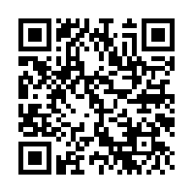  Fiction Non-Fiction | 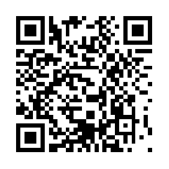  Fiction Non-Fiction
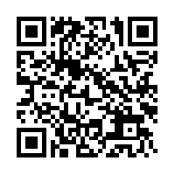  Fiction Non-Fiction | 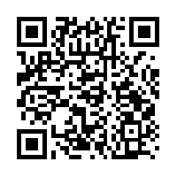  Fiction Non-Fiction
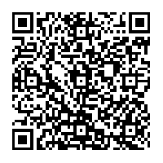  Fiction Non-Fiction | 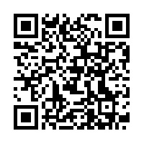  Fiction Non-Fiction
Write 2 examples of non-fiction book titles. They can be real titles or ones you create on your own.
1.
2.

