4th Grade Math Lesson for iPad
Unit:
Objectives/TEKS:
111.16.B.04.09.A - The student is expected to demonstrate translations, reflections, and rotations using concrete models.
111.16.B.04.09.B - The student is expected to use translations, reflections, and rotations to verify that two shapes are congruent.
111.16.B.04.09.C - The student is expected to use reflections to verify that a shape has symmetry.
111.16.B.04.14.C - The student is expected to select or develop an appropriate problem-solving plan or strategy, including drawing a picture, looking for a pattern, systematic guessing and checking, acting it out, making a table, working a simpler problem, or working backwards to solve a problem,
TA TEKS:
2.a. Use a variety of input devices such as mouse, keyboard, disk drive, modem,
voice/sound recorder, scanner, digital video, CD-ROM, or touch screen;
5.a. Acquire information including text, audio, video, and graphics; and
7.a. Use software programs with audio, video, and graphics to enhance learning
experiences;
QRset for iPad/Free/ Internet

Brief Description/Steps of Lesson:
- Distribute Transformations handout to students.
- Demonstrate how to use the QR code reader, QRset.
- Students will scan the QR codes and complete the handout.
End Product:
Students will complete handout on Transformations.

Transformations

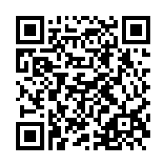 | 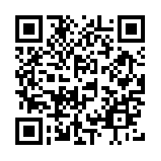
Draw what you see. | Draw what you see.
What type of transformation is shown? | What type of transformation is shown?
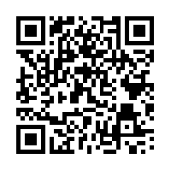 | 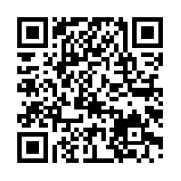  Scan to learn more about Transformations.
Draw what you see. | In your own words, explain what Transformations are.
What type of transformation is shown?

