Lesson Plan - 7th Texas History - Revolution

Unit: Revolution

Objectives/TEKS:

113.19.7.3 - The student understands how individuals, events, and issues related to the Texas Revolution shaped the history of Texas.
113.19.7.3.A - trace the development of events that led to the Texas Revolution, including the Fredonian Rebellion, the Mier y Terán Report, the Law of April 6, 1830, the Turtle Bayou Resolutions, and the arrest of Stephen F. Austin;
113.19.7.3.B - explain the roles played by significant individuals during the Texas Revolution, including George Childress, Lorenzo de Zavala, James Fannin, Sam Houston, Antonio López de Santa Anna, Juan N. Seguín, and William B. Travis;
TA TEKS:

(10) Communication. The student formats digital information for appropriate and effective communication. The student is expected to:
(A) use productivity tools to create effective document files for defined audiences such as slide shows, posters, multimedia presentations, newsletters, brochures, or reports;
(D) demonstrate appropriate use of fonts, styles, and sizes, as well as effective use of graphics and page design to effectively communicate;

Name of App/Cost/Internet or Stand Alone:

Bill Atkinson’s PhotoCard

Adobe Photoshop Express

Brief Description/Steps of Lesson:

- Students will be given a list (attached) of events and people to choose from to create postcards. For example, they may choose to write from the point of view of a Mexican soldier during the Battle of the Alamo. Or, they might be an American settler during the Runaway Scrape. Students will create 3-5 postcards.
End Product:
3-5 postcards representing various people from assorted events during the Texas Revolution.

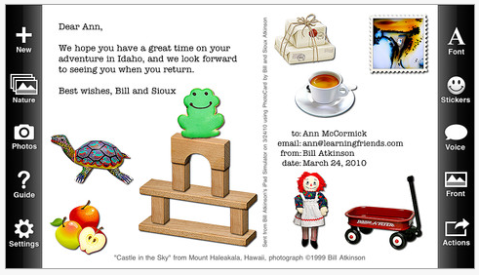

Choose 1 Event from the list below.
Battle of Gonzalez
Battle of Goliad
Battle of San Antonio
The Runaway Scrape
Battle of the Alamo
Battle of San Jacinto
The Consultation
Battle of Velasco
Turtle Bayou Resolutions
Convention of 1836

Choose 1 person from the list below.
An American/Texan settler
A Mexican settler
A Mexican soldier
A Texan/American soldier
Santa Anna
Sam Houston
William B. Travis
Scout
James Fannin
A Mexican army officer
A Texan army officer

