8th Grade Science Lesson for IPad

Unit: 8th - Chemistry
Objectives/TEKS:

112.20.B.08.5.B - identify that protons determine an elements identity and valence electrons determine its chemical properties, including reactivity;
112.20.B.08.5.D - recognize that chemical formulas are used to identify substances and determine the number of atoms of each element in chemical formulas containing subscripts;

TA TEKS:

(2) Foundations. The student uses data input skills appropriate to the task. The student is expected to:
(A) demonstrate proficiency in the use of a variety of input devices such as mouse/track pad, keyboard, microphone, digital camera, printer, scanner, disk/disc, modem, CD-ROM, or joystick;
5) Information acquisition. The student acquires electronic information in a variety of formats, with appropriate supervision. The student is expected to:
(A) identify, create, and use files in various formats such as text, bitmapped/vector graphics, image, video, and audio files;

Name of App/Cost/Internet or Stand Alone:
QRset/Free/Internet

Brief Description/Steps of Lesson:

- Teacher will display QR codes (attached) around the room or at various lab stations.
- Students will open the QRset app. They will use the app to scan the QR codes and fill in the handout (also attached).

End Product: Students will complete handout on Elements, Compounds, and Mixtures.

Elements, Compounds, or Mixtures
Directions: Scan the QR codes. In the first box of each column, you’ll put the correct definition. In the other boxes, you will write the name of the object and whether it is an element, compound, or mixture. Example: Carbon – Element. Also, all of the boxes will not be filled.
Element | Compound | Mixture
Definition: | Definition: | Definition:

QR Codes for Elements, Compounds, and Mixtures
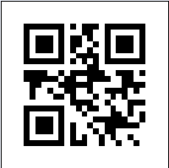
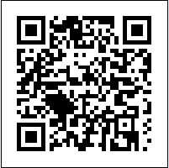
Sodium Water Soil

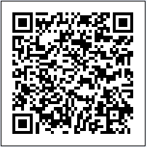
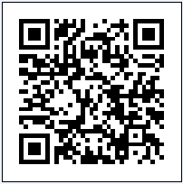
Coffee Oxygen Alcohol
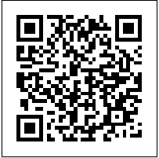

Carbon Dioxide Cake Batter Air
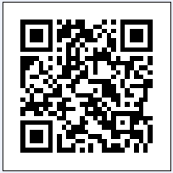
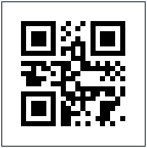
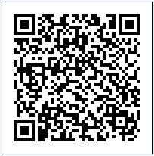

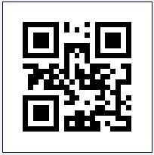
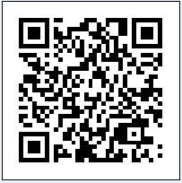
Soap Iron Salt Water

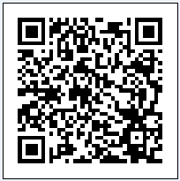
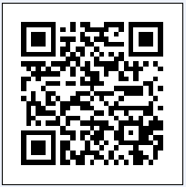
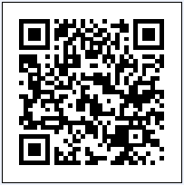
Ice Cream Nitrogen Eggs

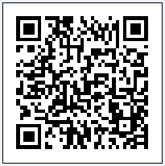
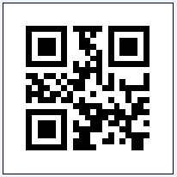
Blood Table Salt Nail Polish

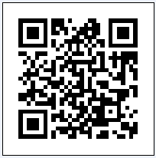
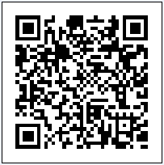
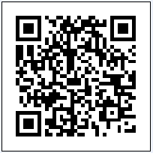
Milk Cola Elements – Definition

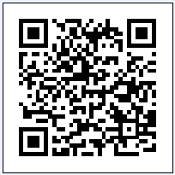
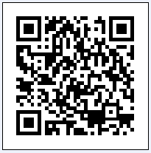
Compounds – Definition Mixture – Definition

