3rd Grade Social Studies Lesson for iPad
Unit: Science, Technology, and Society

Objectives/TEKS:

113.14.3.16 - The student understands how individuals have created or invented new technology and affected life in various communities, past and present.
113.14.3.16.A - identify scientists and inventors, including Jonas Salk, Maria Mitchell, and others who have discovered scientific breakthroughs or created or invented new technology such as Cyrus McCormick, Bill Gates, and Louis Pasteur; and
113.14.3.16.B - identify the impact of scientific breakthroughs and new technology in computers, pasteurization, and medical vaccines on various communities.
113.14.3.17 - The student applies critical-thinking skills to organize and use information acquired from a variety of valid sources, including electronic technology.

TA TEKS:

(5) Information acquisition. The student acquires electronic information in a variety of formats, with appropriate supervision. The student is expected to:
(A) acquire information including text, audio, video, and graphics; and
(7) Solving problems. The student uses appropriate computer-based productivity tools to create and modify solutions to problems. The student is expected to:
(A) use software programs with audio, video, and graphics to enhance learning experiences;
(B) use appropriate software to express ideas and solve problems including the use of word processing, graphics, databases, spreadsheets, simulations, and multimedia; and
(C) use a variety of data types including text, graphics, digital audio, and video.
(10) Communication. The student formats digital information for appropriate and effective communication. The student is expected to:
(A) use font attributes, color, white space, and graphics to ensure that products are appropriate for the defined audience;
(B) use font attributes, color, white space, and graphics to ensure that products are appropriate for the communication media including multimedia screen displays, Internet documents, and printed materials.

Name of App/Cost/Internet or Stand Alone:
QRSet/Free/Internet
Story Kit/Free/Stand Alone

Brief Description/Steps of Lesson:

- Students may be placed into groups or handouts could be separated into stations. Students will use the QRSet app to scan the QR codes on the handouts and solve the clues.
- Teacher may create a key or use whole class discussion to reveal the answers.
- Students will select one of the people identified by the clues to create a story using the Story Kit app.
- Story must include: name of the person, what they are famous for, and the impact of their discovery or invention.

End Product:
Students will create a book about one of the famous scientists and inventors.
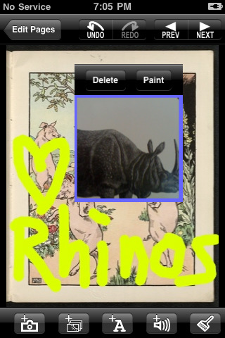
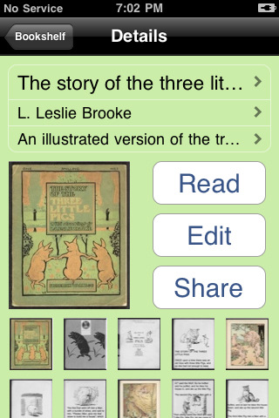

Who Am I?
Person #1
Scan the QR codes below for clues. Copy each clue on the lines below the QR code. In the last box, scan for a picture of the person, then write the name of the scientist or inventor.

Clue #1  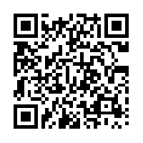  _________________________________________  _________________________________________  _________________________________________ | Clue #2  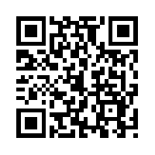  _________________________________________  _________________________________________  _________________________________________
Clue #3  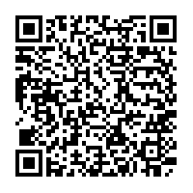  _________________________________________  _________________________________________  _________________________________________ | Who Am I?  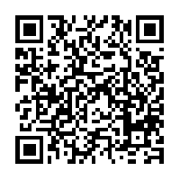  _________________________________________

Who Am I?
Person #2
Scan the QR codes below for clues. Copy each clue on the lines below the QR code. In the last box, scan for a picture of the person, then write the name of the scientist or inventor.

Clue #1  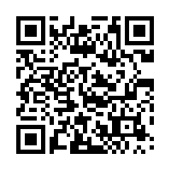  _________________________________________  _________________________________________  _________________________________________ | Clue #2  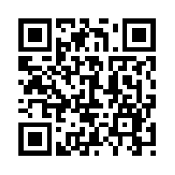  _________________________________________  _________________________________________  _________________________________________
Clue #3  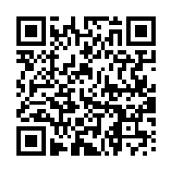  _________________________________________  _________________________________________  _________________________________________ | Who Am I?  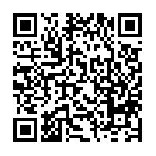  _________________________________________

Who Am I?
Person #3
Scan the QR codes below for clues. Copy each clue on the lines below the QR code. In the last box, scan for a picture of the person, then write the name of the scientist or inventor.

Clue #1  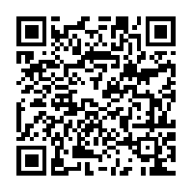  _________________________________________  _________________________________________  _________________________________________ | Clue #2  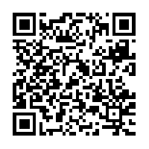  _________________________________________  _________________________________________  _________________________________________
Clue #3  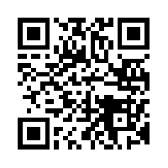  _________________________________________  _________________________________________  _________________________________________ | Who Am I?  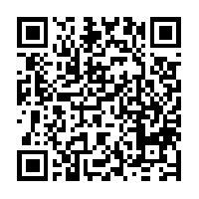  _________________________________________

Who Am I?
Person #4
Scan the QR codes below for clues. Copy each clue on the lines below the QR code. In the last box, scan for a picture of the person, then write the name of the scientist or inventor.

Clue #1  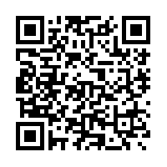  _________________________________________  _________________________________________  _________________________________________ | Clue #2  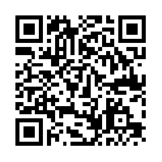  _________________________________________  _________________________________________  _________________________________________
Clue #3  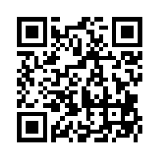  _________________________________________  _________________________________________  _________________________________________ | Who Am I?  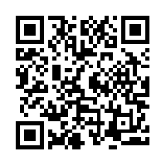  _________________________________________

Who Am I?
Person #5
Scan the QR codes below for clues. Copy each clue on the lines below the QR code. In the last box, scan for a picture of the person, then write the name of the scientist or inventor.

Clue #1  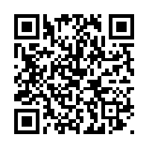  _________________________________________  _________________________________________  _________________________________________ | Clue #2  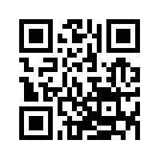  _________________________________________  _________________________________________  _________________________________________
Clue #3  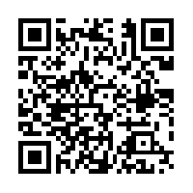  _________________________________________  _________________________________________  _________________________________________ | Who Am I?    

